

|  |
| --- |
| Apparel & Footwear |
| **Prepacks** |
| Argentis Consulting |

**Prepacks Process**

**www.argentisconsulting.com**

The following steps describes the Prepacks process.

The Pack or Kit is created as a Style in Apparel and Footwear, with its own Code and Description.

Example: 5-Pack Short Sleeve Baby Body.

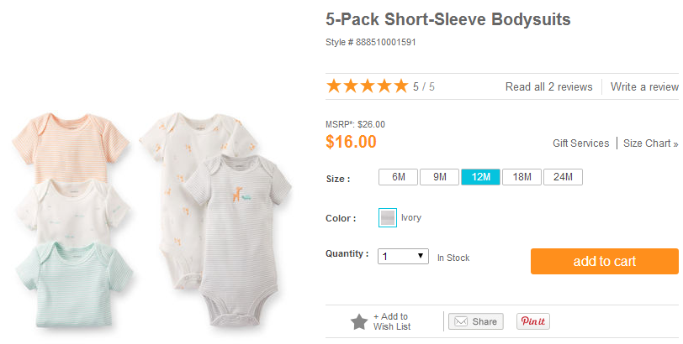

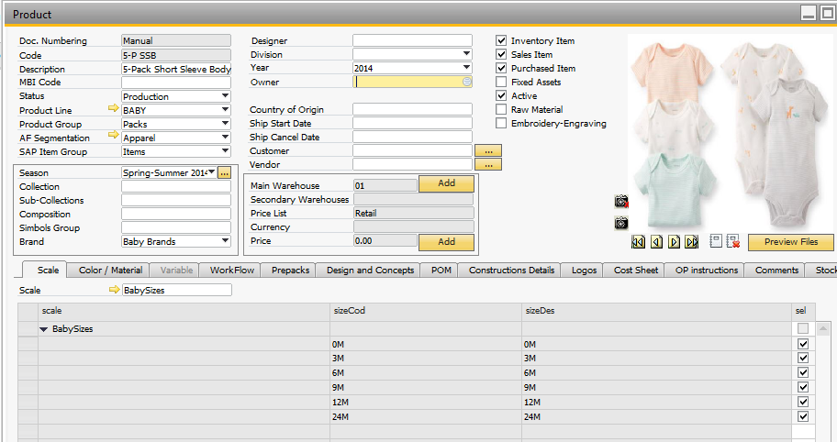

The Prepack will have a scale and color information.

It´s possible to detail the items that compose the Kit in the BOM.

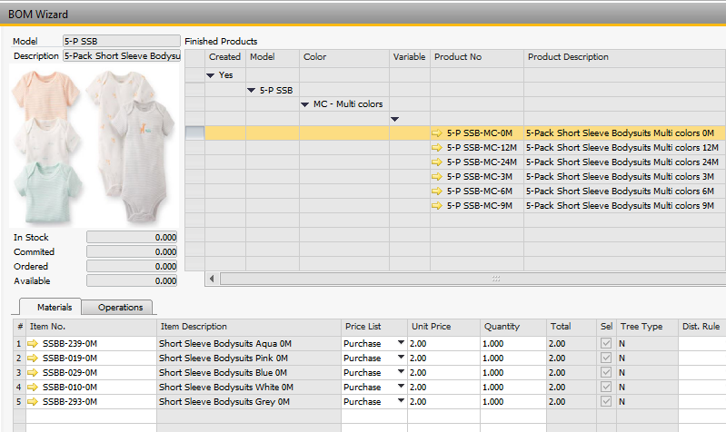

This way it´s possible to configure several Prepacks per Style, and the Prepack may have items of different Styles, like for example a Kit with a body, socks and a hat.

By creating the Prepacks as a Style allows to create Purchasing Orders and Sales Orders for the Prepack. This way is available the information of quantities in stock in a warehouse per each prepack.

About migrating initial stock, it´s possible to migrate the quantities for packs during the project.

Stock visualization in the Style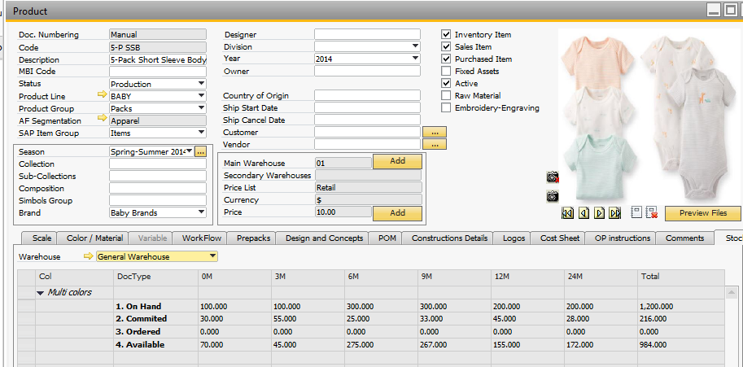

Crystal Report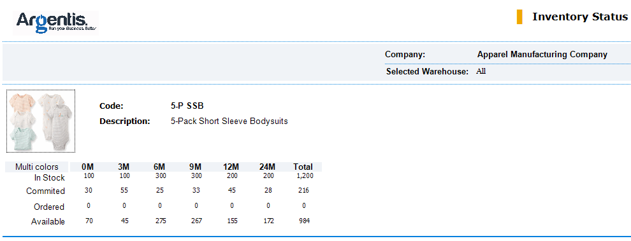

The picking and packing process is done also per Prepack.

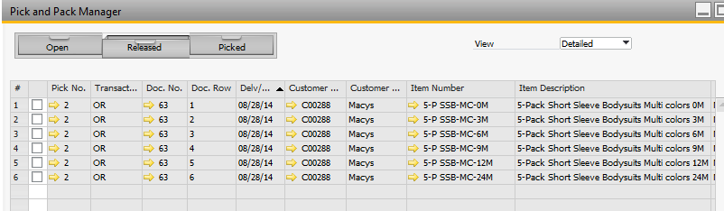

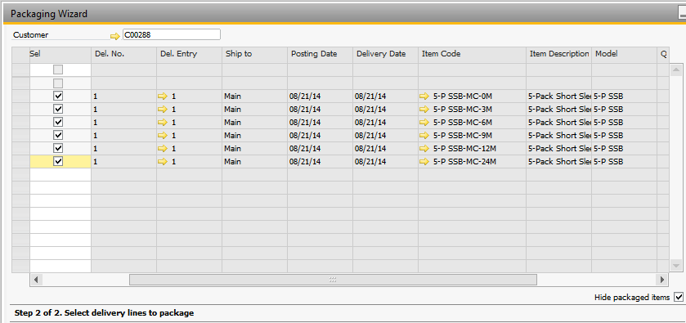

We Create the Prepack as a Style. Then is created the BOM with the Items that compose the Prepack.

The BOM we create is a Production BOM.

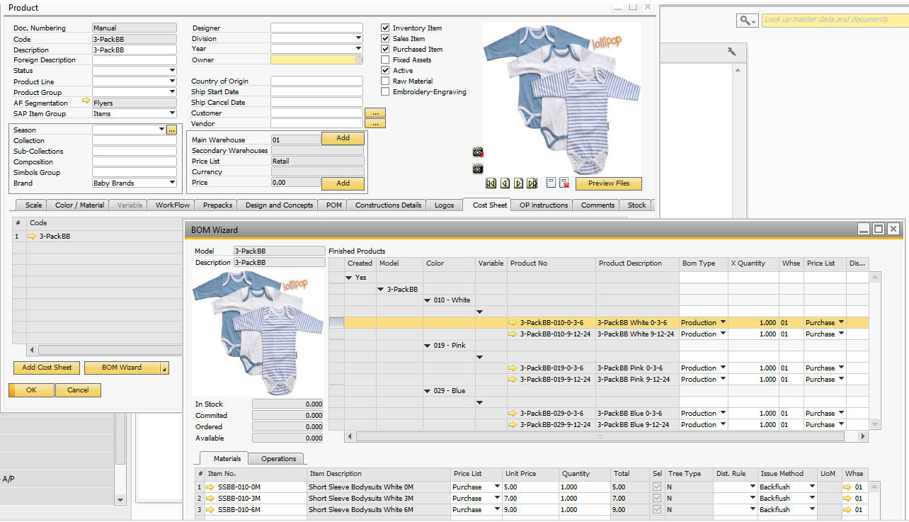

In the BOM, you can also select the Price List of the SKUs.

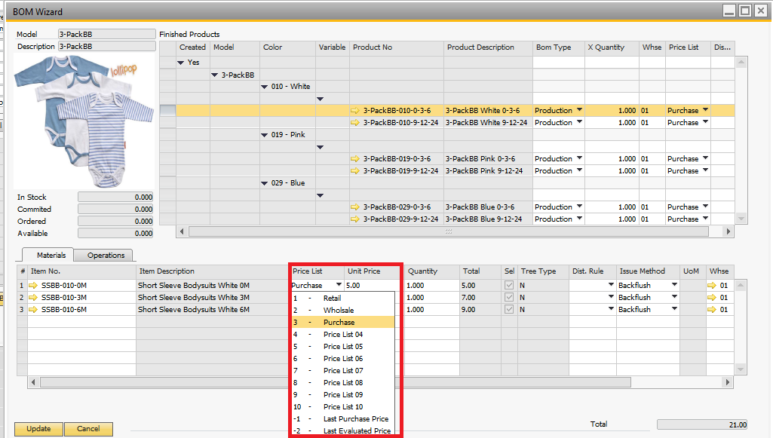



**www.argentisconsulting.com**

|  |  |
| --- | --- |
| **USA**  9744 NW 45th Lane  Doral, FL 33178  info@argentisconsulting.com | **ARGENTINA**  Ávila y Zarate 2048  Cerro de la Rosas, Córdoba,  CP 5009  Córdoba - Argentina  info@argentisconsulting.com |
| **CARIBEAN**  City View Plaza – Suite 301  48 Road 165  Guaynabo, PR. 00968  Puerto Rico  caribe@argentisconsulting.com | **SPAIN**  C/ Juan Bravo N° 3 A 28006  Phone: (+34) 91 123 7263  Madrid - Spain  info@argentisconsulting.com |

**INFORMACIÓN DE CONTACTO**

**Argentis Consulting** is dedicated to the development, distribution   
and support of recognized certified solutions for SAP Business One.   
As an SAP Software Service Provider Partner with Gold Status.